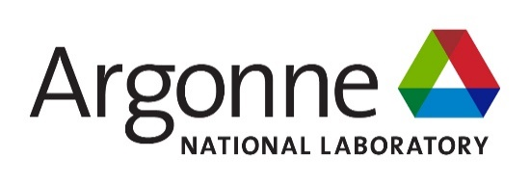

ABSTRACT SUBMITTAL FORM

2022 Mo-99 International Symposium

Abstract submitted by: Click or tap here to enter text.

Expected Presenter: Click or tap here to enter text.

Poster Session Request: Yes ☐ No ☐

Please include your abstract below.

Abstract Title: Bold, 14 pt

A.B. Author and C.D. Author (11 Pt)
Department
Organization, Street, Postal Code City – Country

ABSTRACT

Your abstract must be in English. It should be a short abstract of 150 words describing key elements of your contribution and its conclusions. This paragraph should be typeset in block mode, 11 pt, with margins of 1 in.

Please submit your abstract in Microsoft Word format

Please return this form along with Publication Release form by e-mail to mo99@anl.gov by August 19, 2022.

